**Jenkins Master Slave Creation**

# Start Jenkins master server which we have created already.

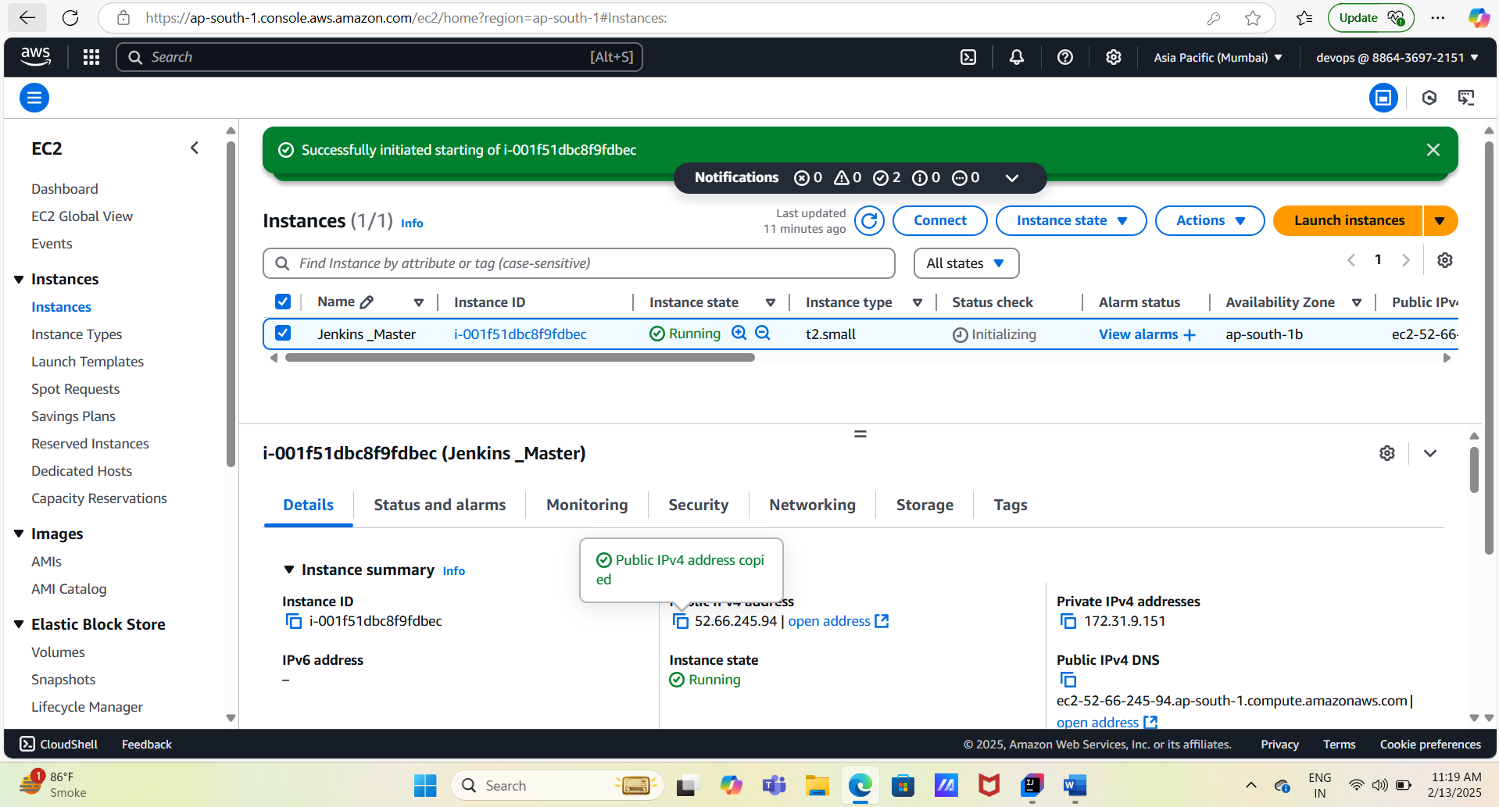

# Create new EC-2 server as Jenkins slave server with amazon Linux / t2. micro type.

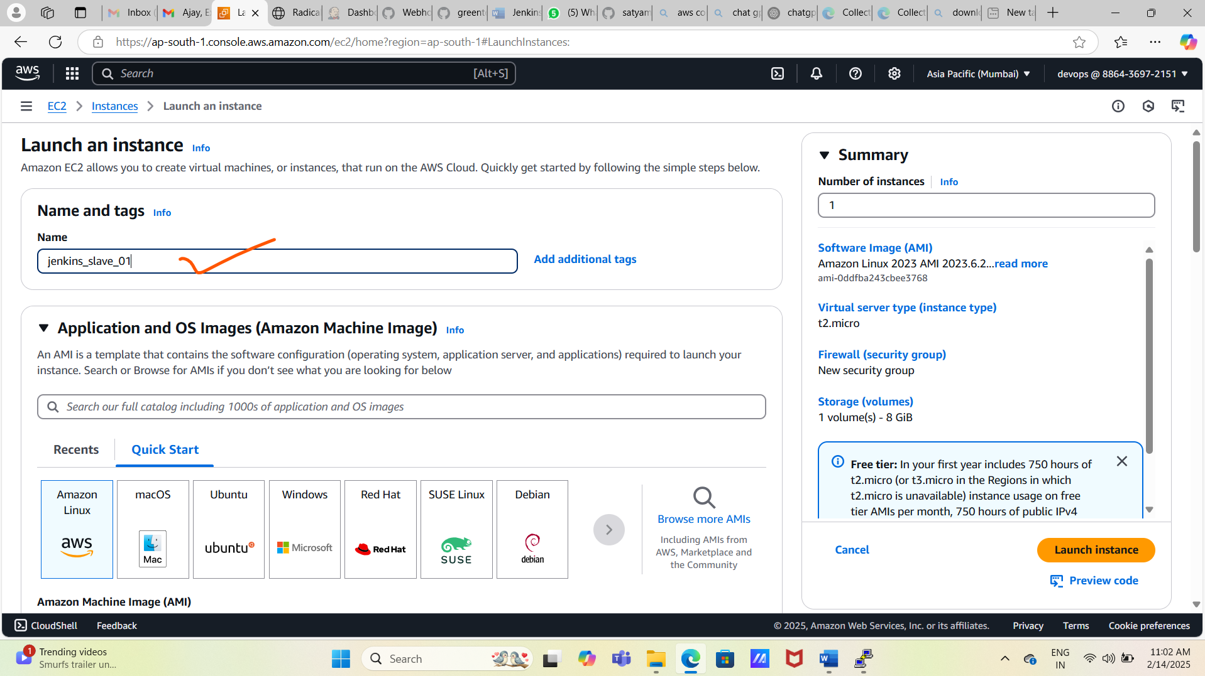

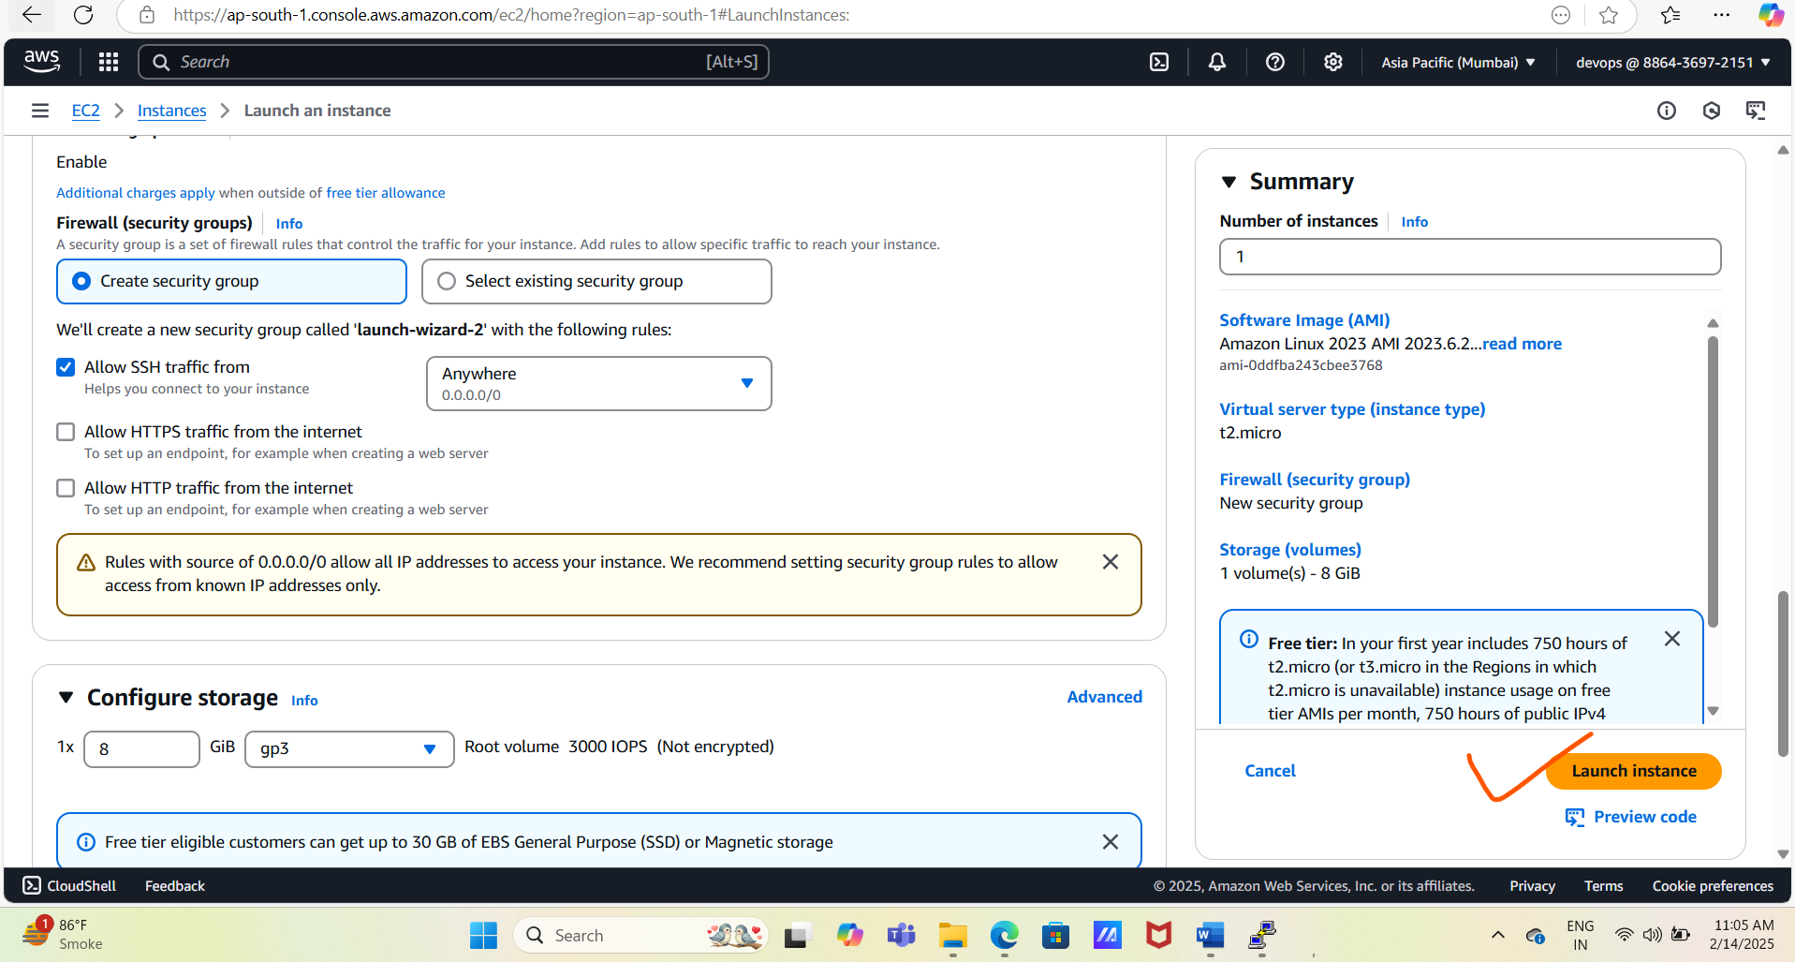

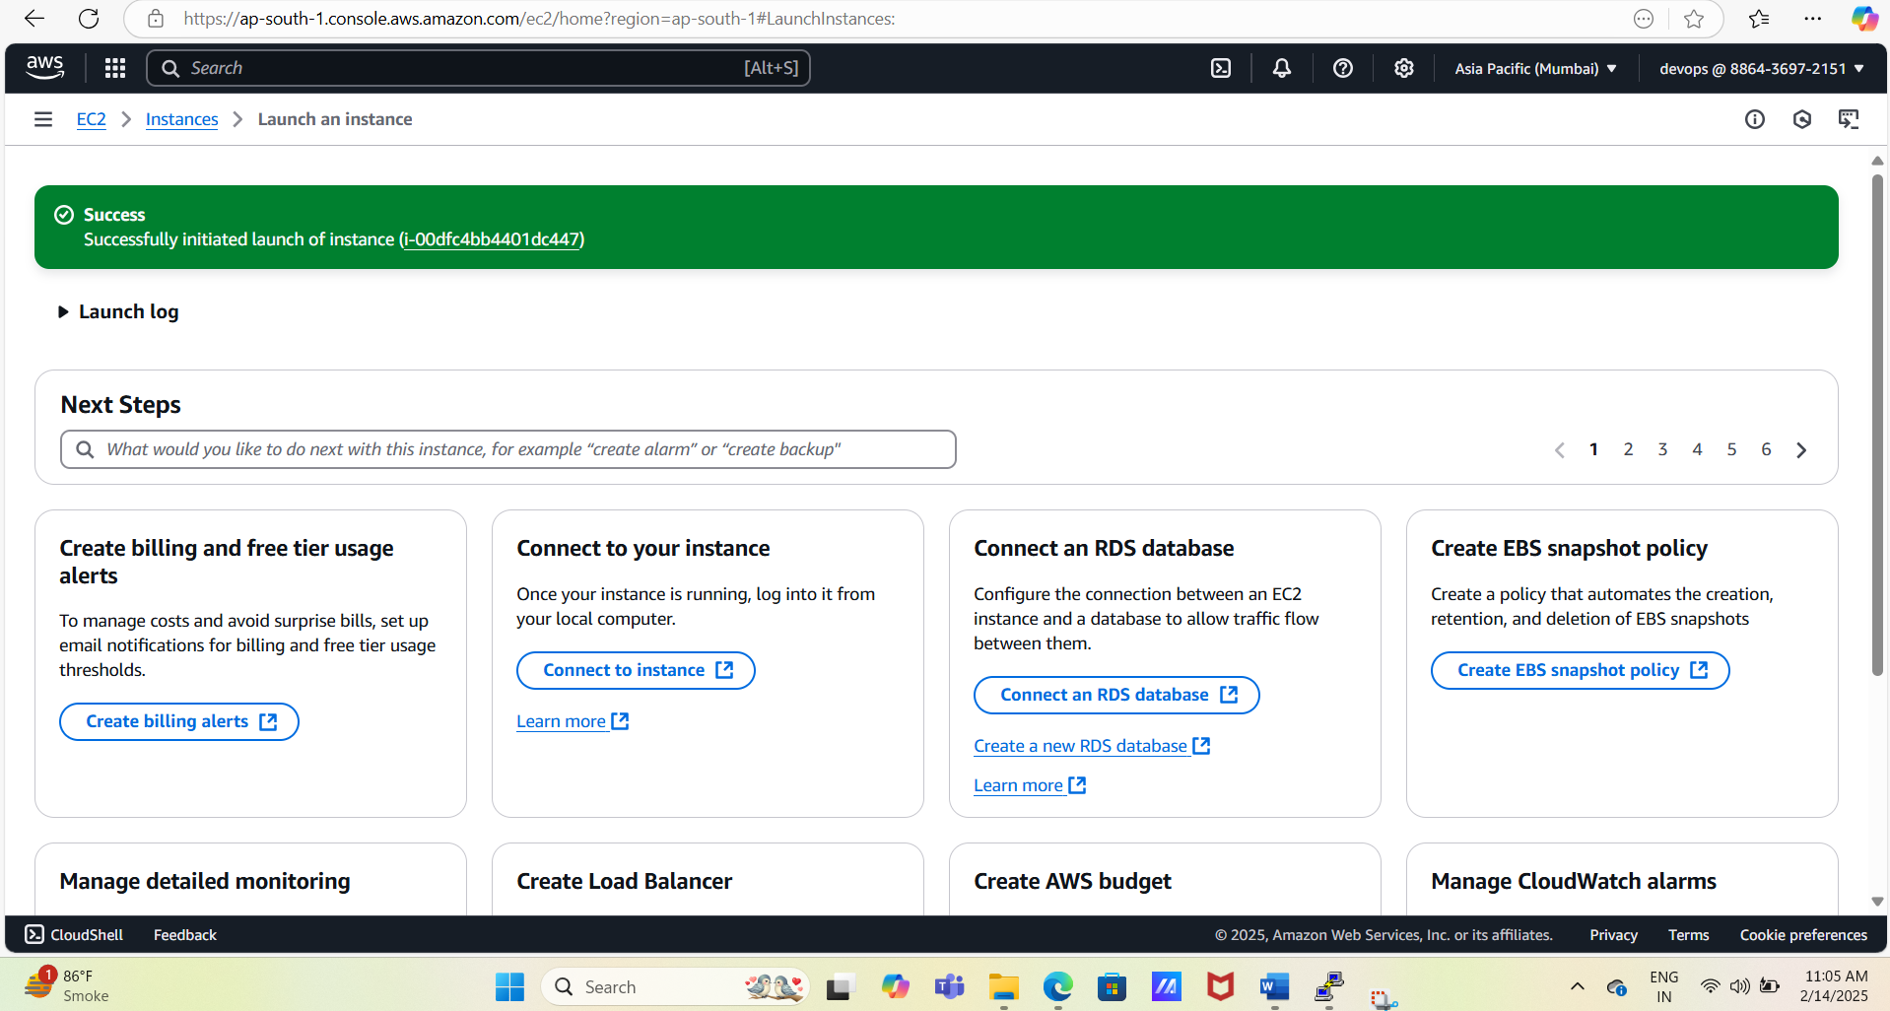

#Edit security group and allow all traffic

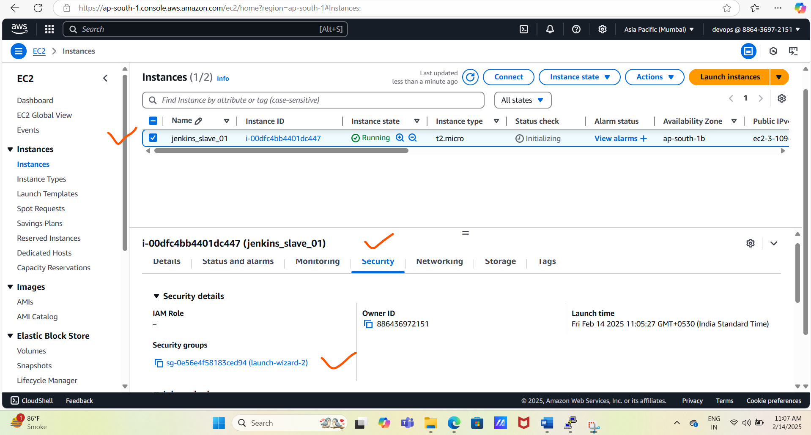

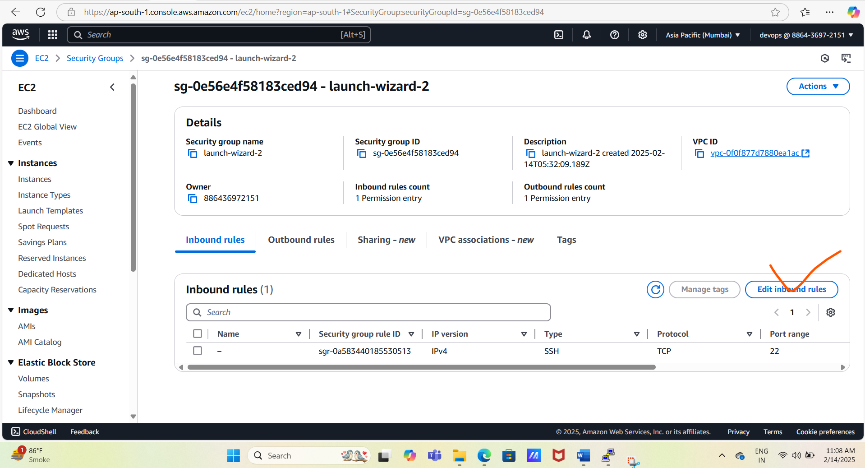

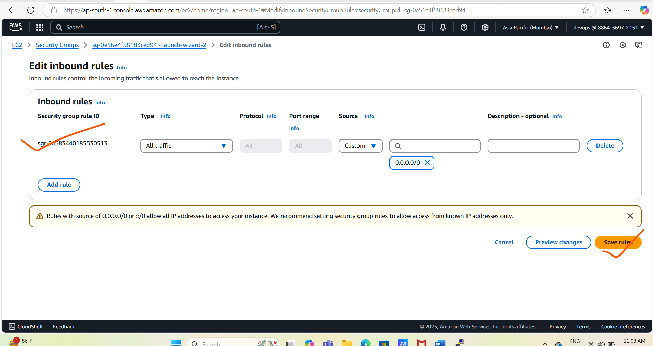

# Take Jenkins slave access using putty

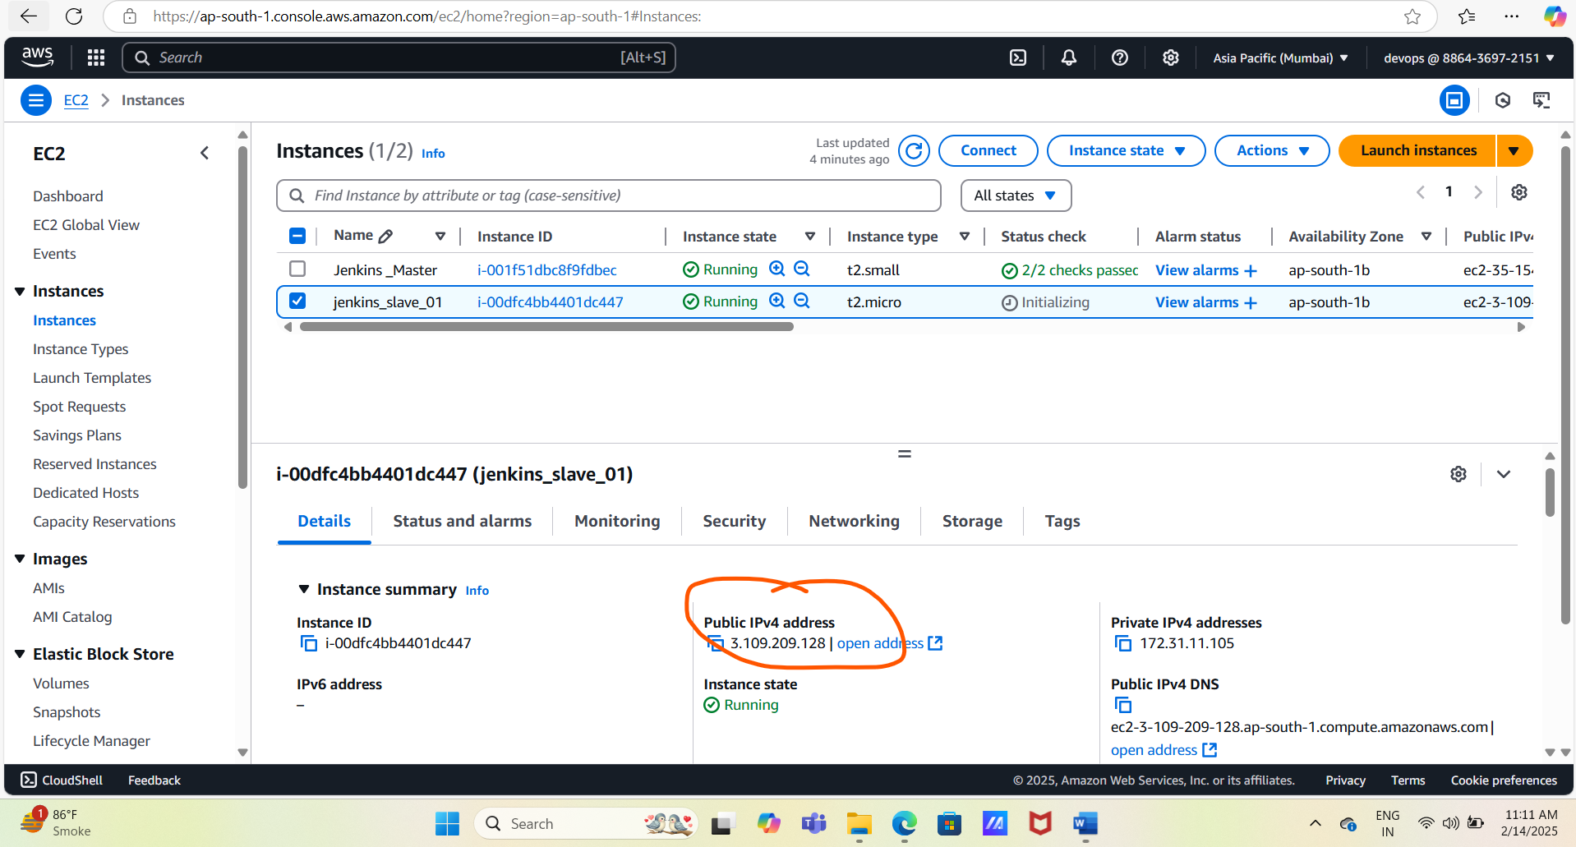

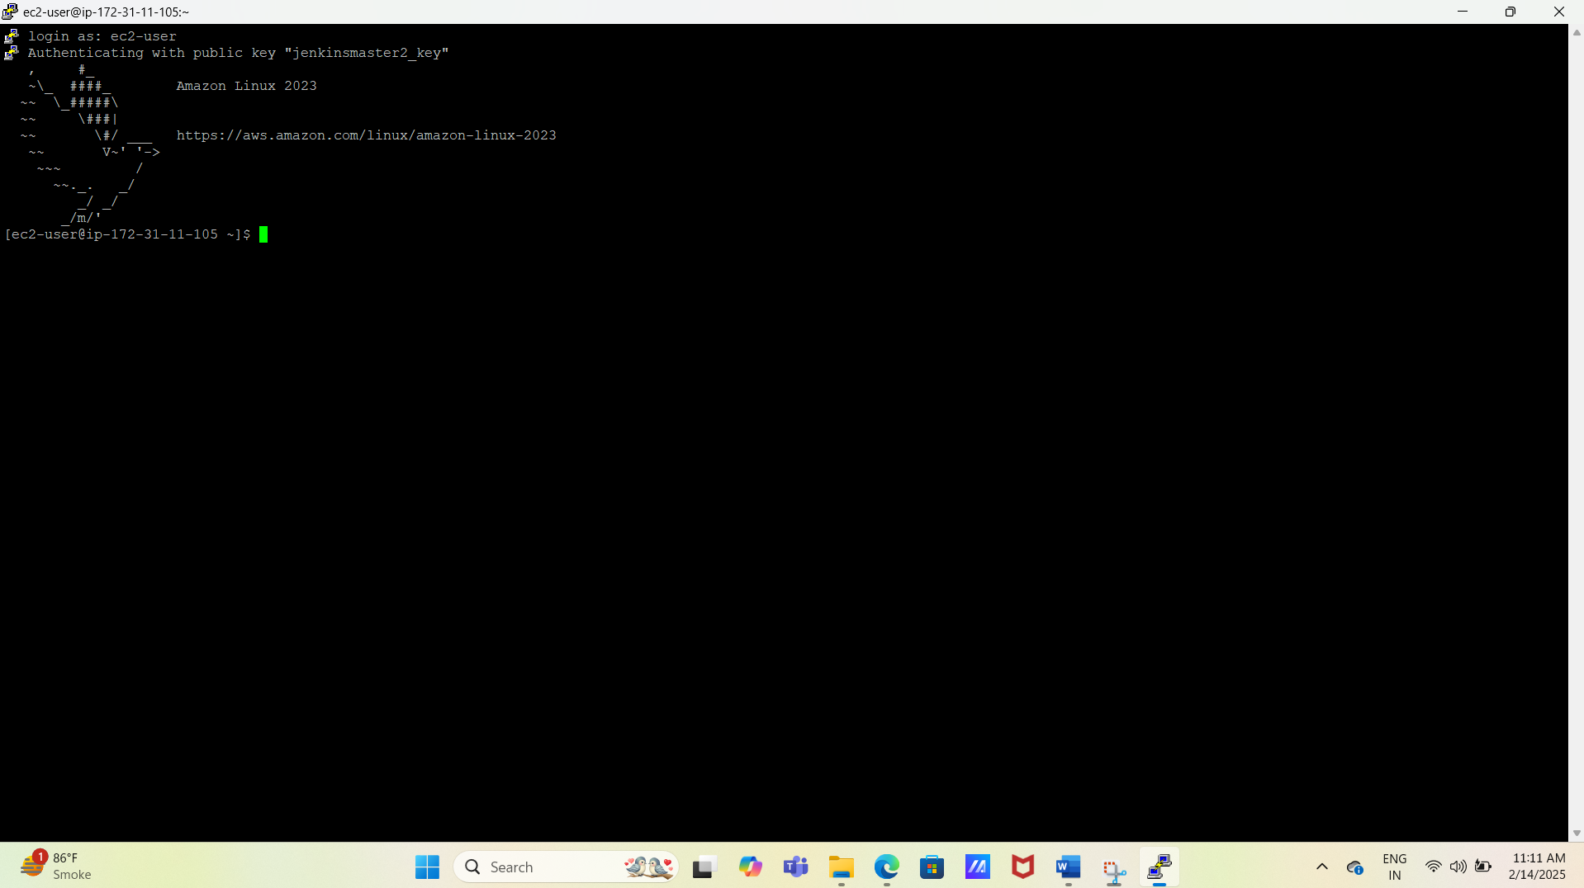

# Install Git , Java 21 and Maven using below commands on slave Jenkins server.

yum -y update

yum install -y git

yum install -y java-21-amazon-corretto

yum install -y java-21-amazon-corretto-devel

cd /opt

sudo wget https://dlcdn.apache.org/maven/maven-3/3.9.9/binaries/apache-maven-3.9.9-bin.tar.gz

sudo tar xvf apache-maven-3.9.9-bin.tar.gz

ls -ltr

cd

echo "export M2_HOME=/opt/apache-maven-3.9.9" >> .bash_profile

echo "export M2=$M2_HOME/bin" >> .bash_profile

echo "export PATH=$M2:$PATH" >> .bash_profile

source ~/.bash_profile

echo $M2_HOME

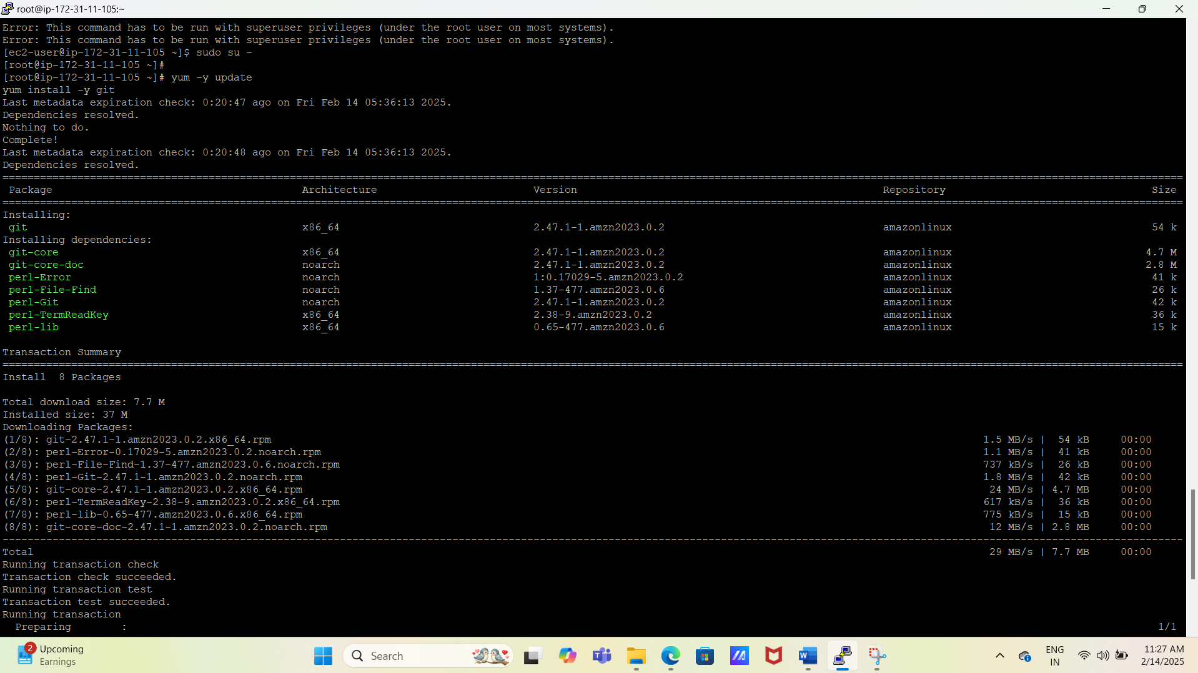

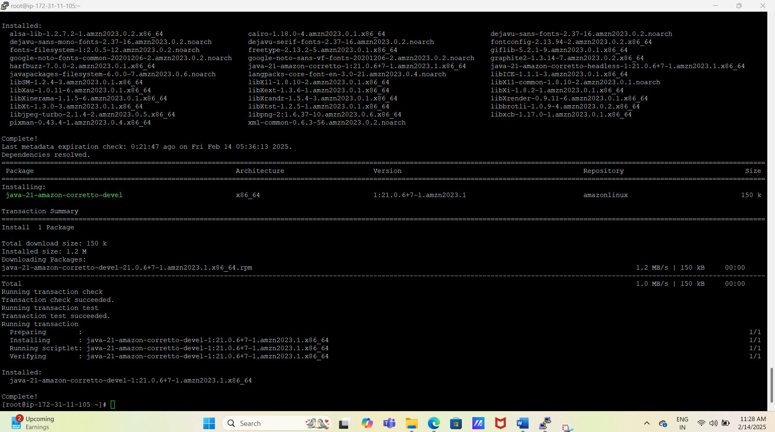

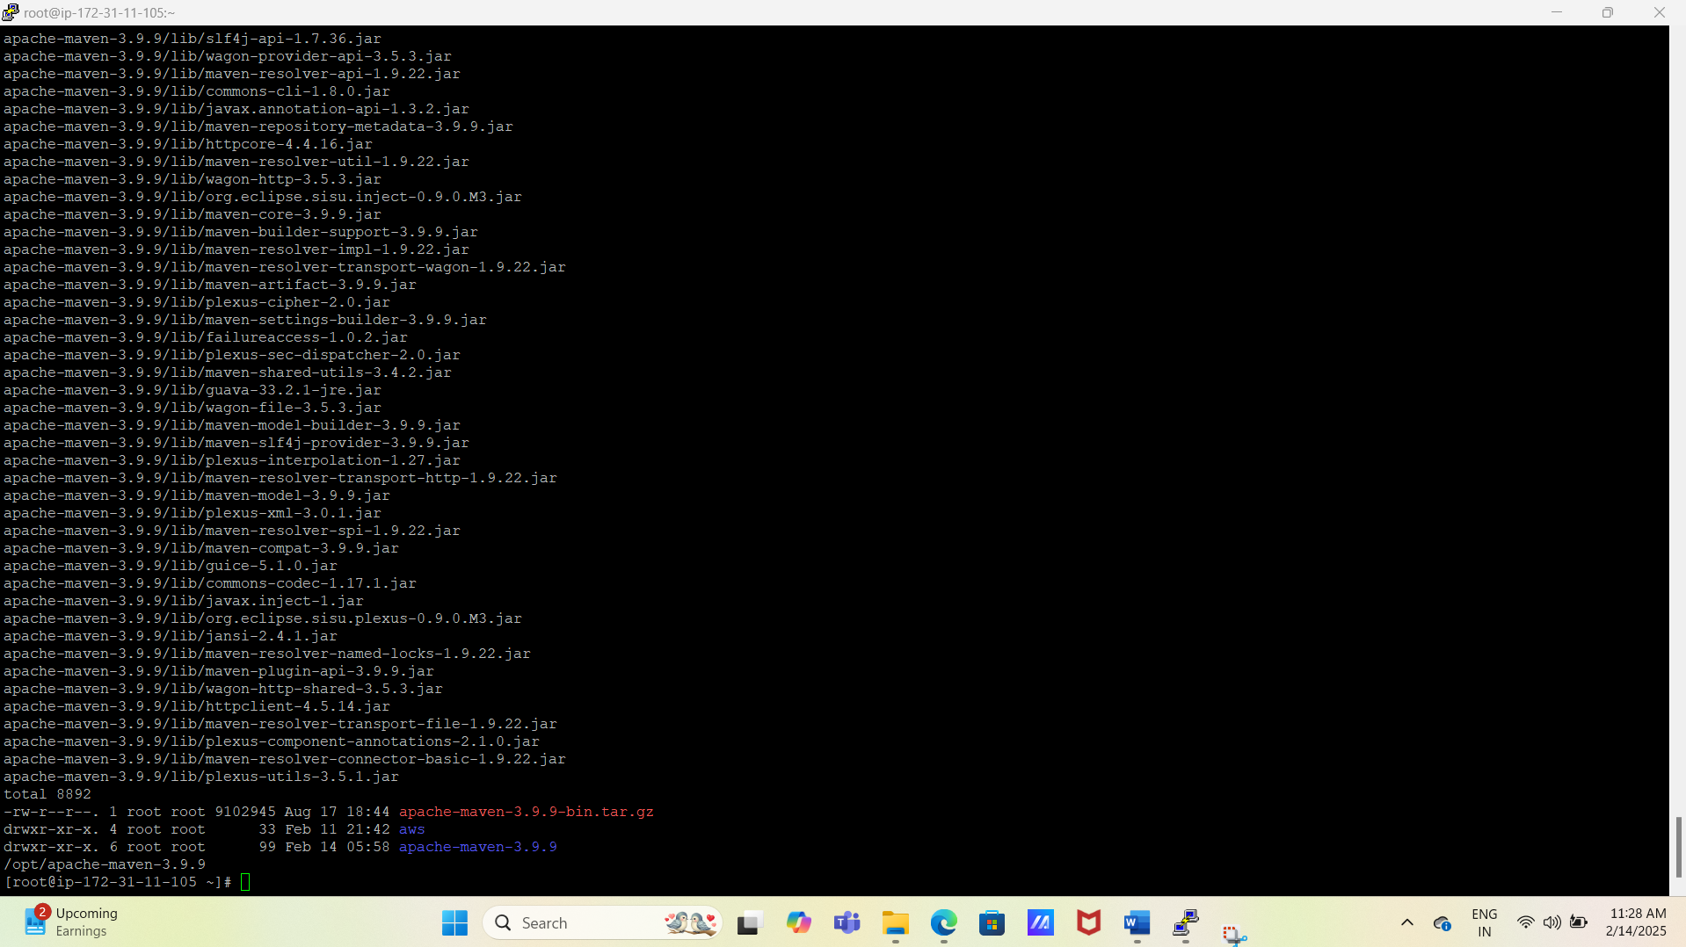

# Check version of git, java , maven using below command

git --version; java --version; /opt/apache-maven-3.9.9/bin/mvn --version

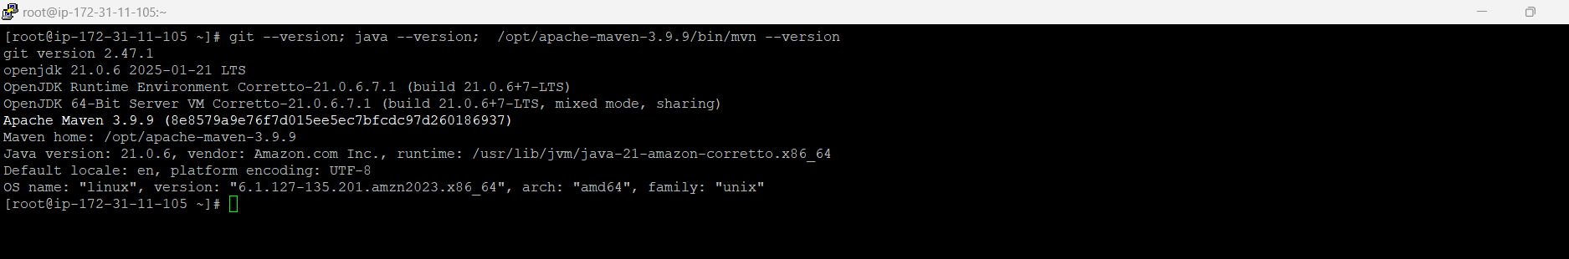

#Create user and add the user to wheel group using below command.

useradd jenkins-slave-01

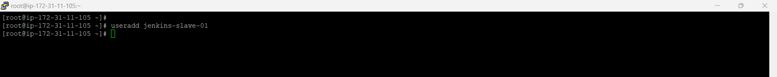

# Create SSH Keys for Jenkins slave using below commands.

sudo su - jenkins-slave-01

ssh-keygen -t rsa -N "" -f /home/jenkins-slave-01/.ssh/id_rsa

cd .ssh

cat id_rsa.pub > authorized_keys

chmod 700 authorized_keys

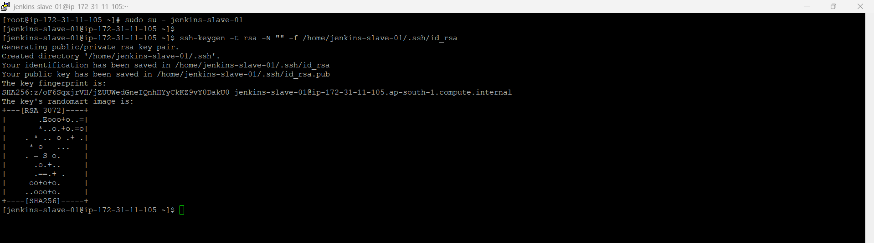

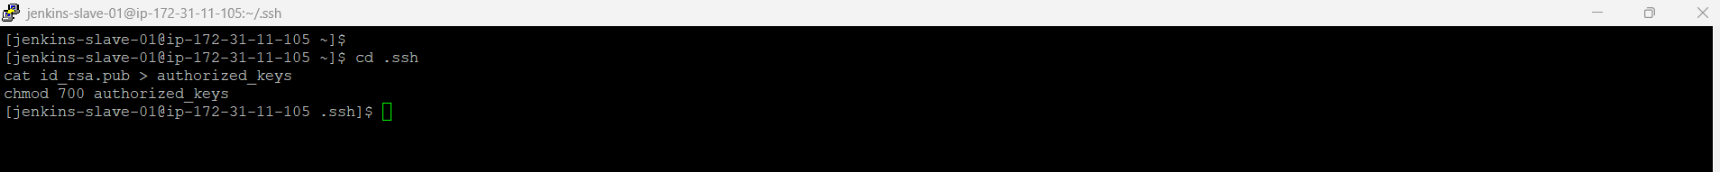

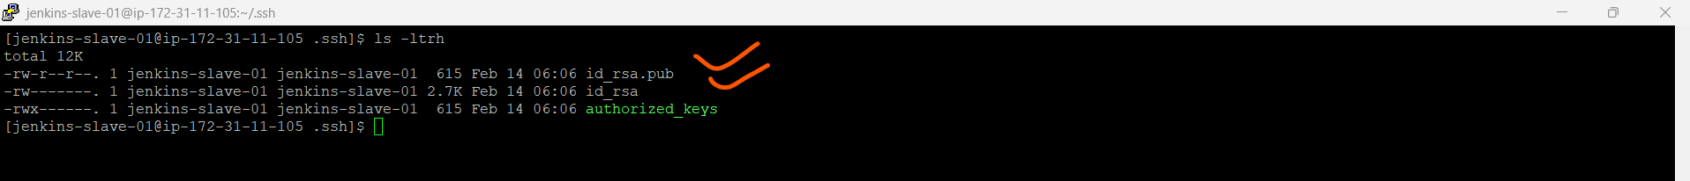

# Login to Jenkins master and scan the key for Jenkins slave server.

mkdir -p /var/lib/jenkins/.ssh



cd /var/lib/jenkins/.ssh



ssh-keyscan -H 172.31.11.105 >> /var/lib/jenkins/.ssh/known_hosts

Note: -User Jenkins slave server private IP in the above command.

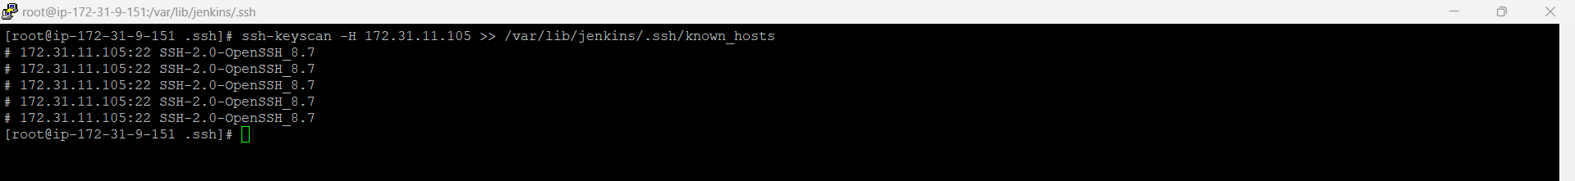

chown jenkins:jenkins known_hosts

chmod 700 known_hosts



# Configure the Slave using Manage Jenkins (In the master jenkins)

Login Jenkins and open manage Jenkins tab

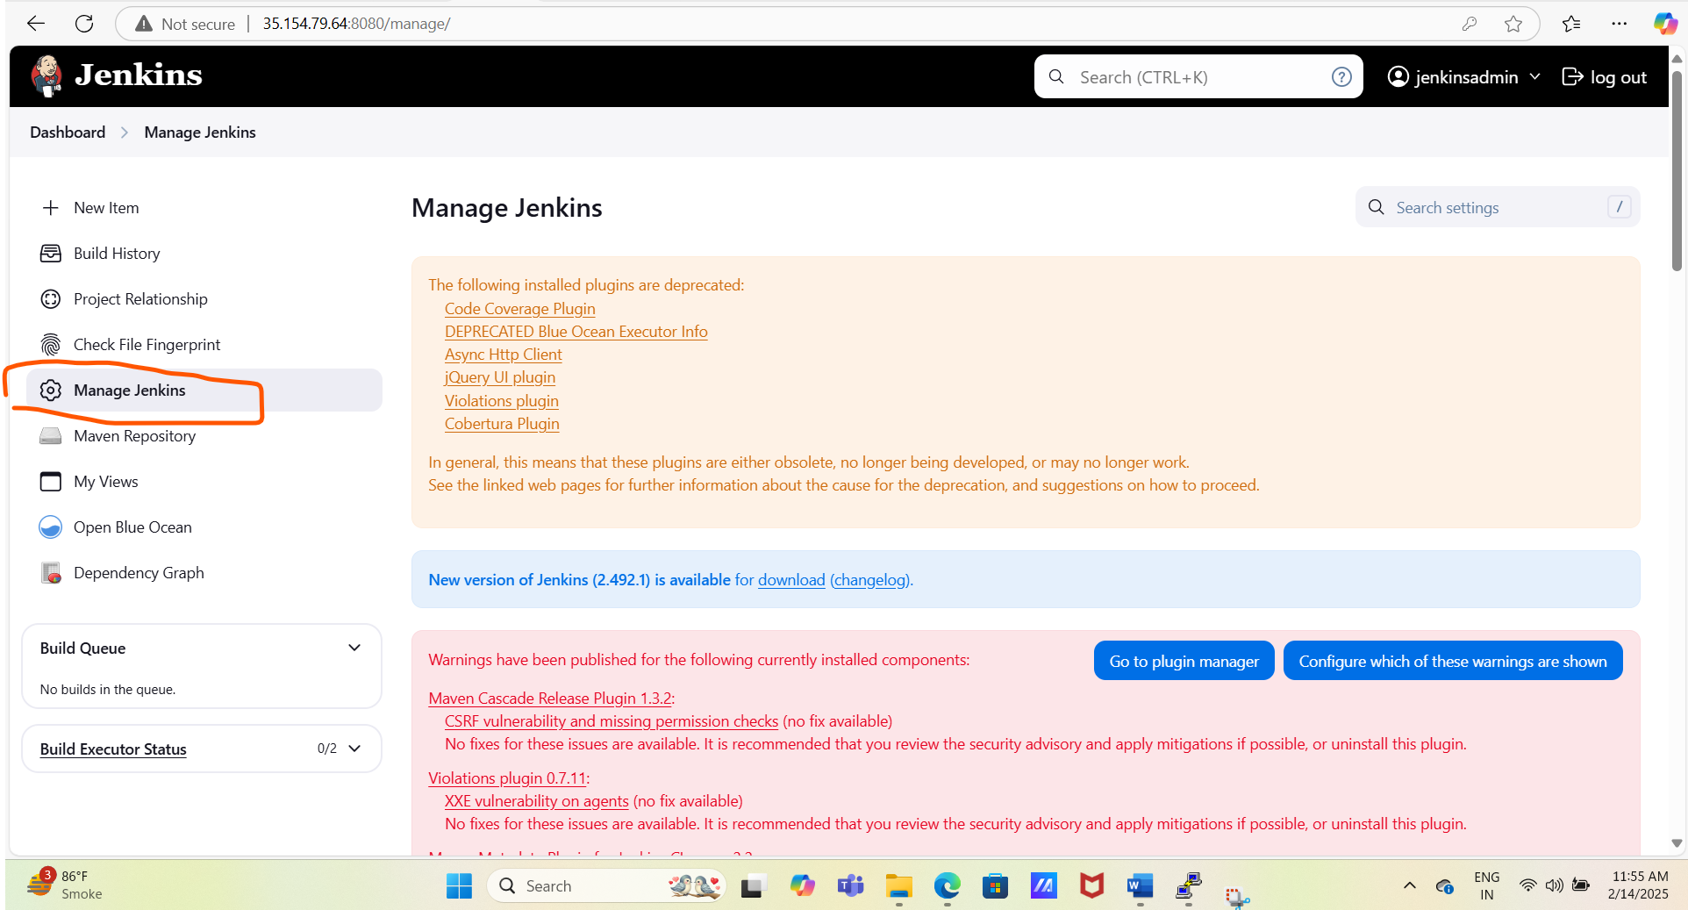

Open Node tab of manage Jenkins

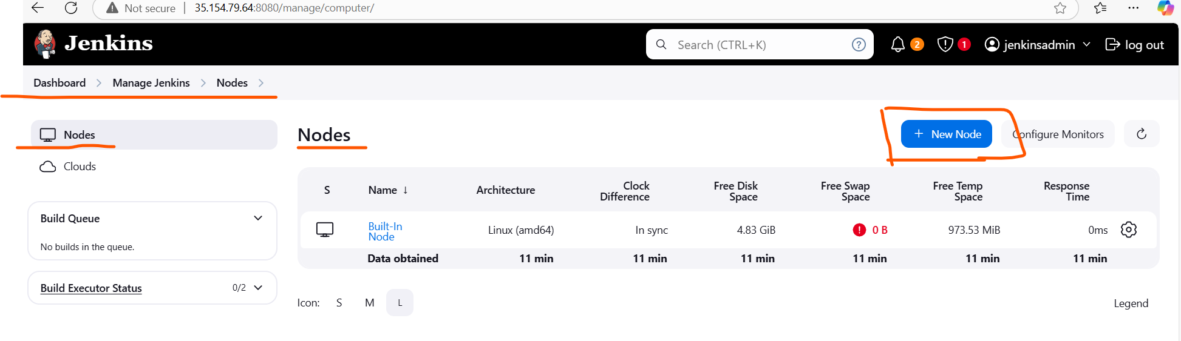

Add newly created node as name with Jenkins-slave-01 and select permanent agent option and click on create and procced to add descriptions and node details using UI

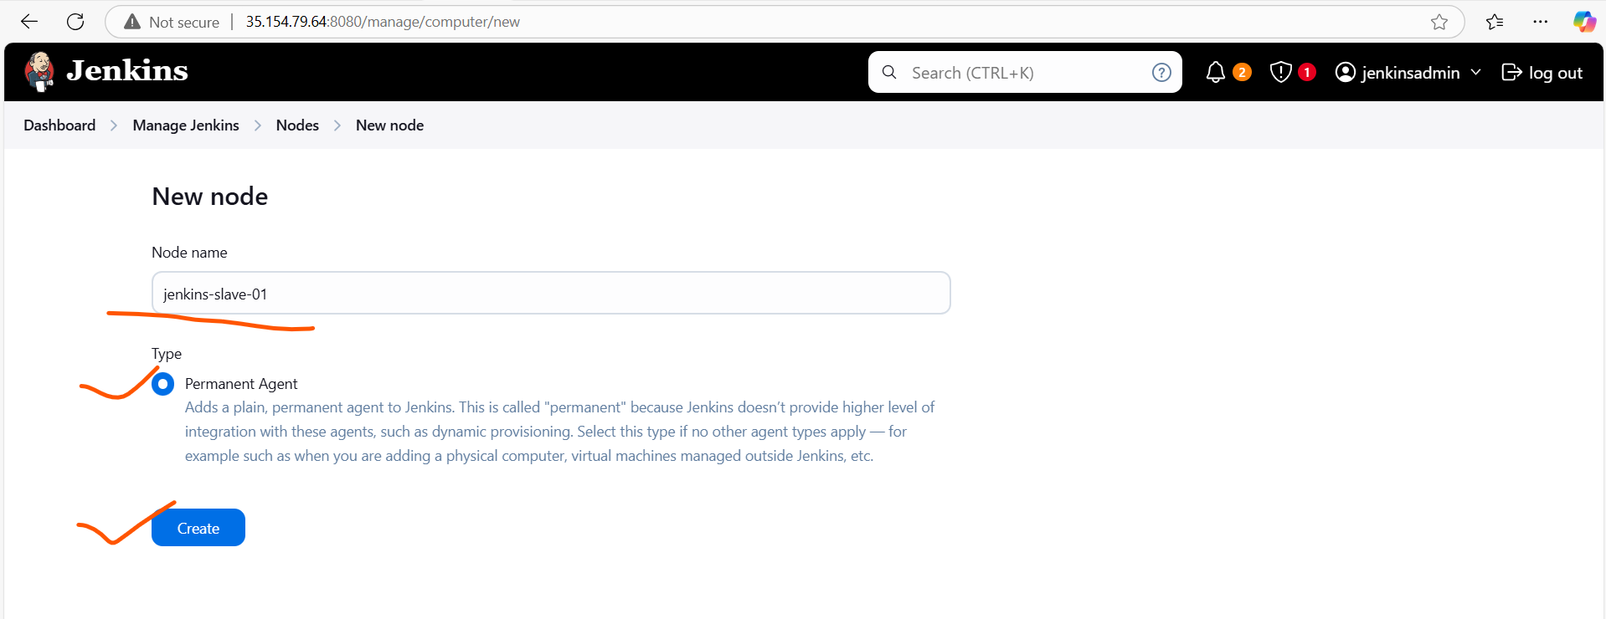

Add descriptions

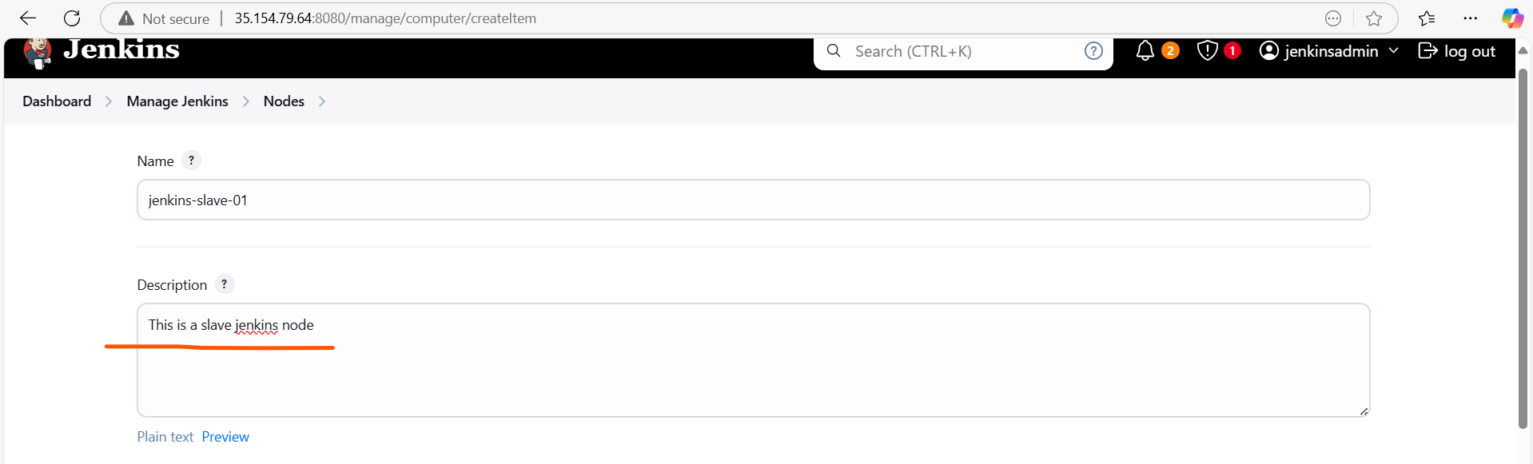

Add job executor (How many jobs you want to run parallelly)

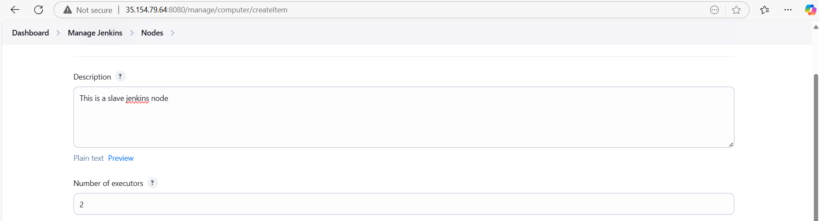

Add Jenkins slave home directory path



Add Label, Launch method as SSH, and Host as slave private IP address

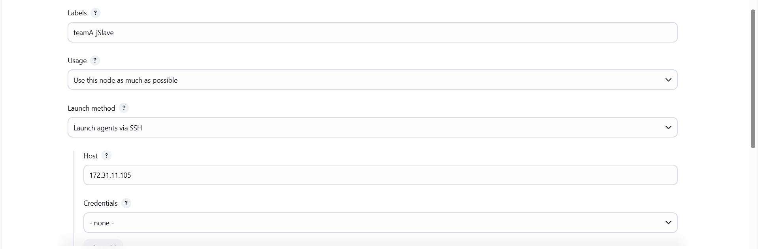

Now we have to add credentials (So first we create credentials and then we will add the same)

Creation of credentials

-Go to the manage Jenkins

-Go to the credentials

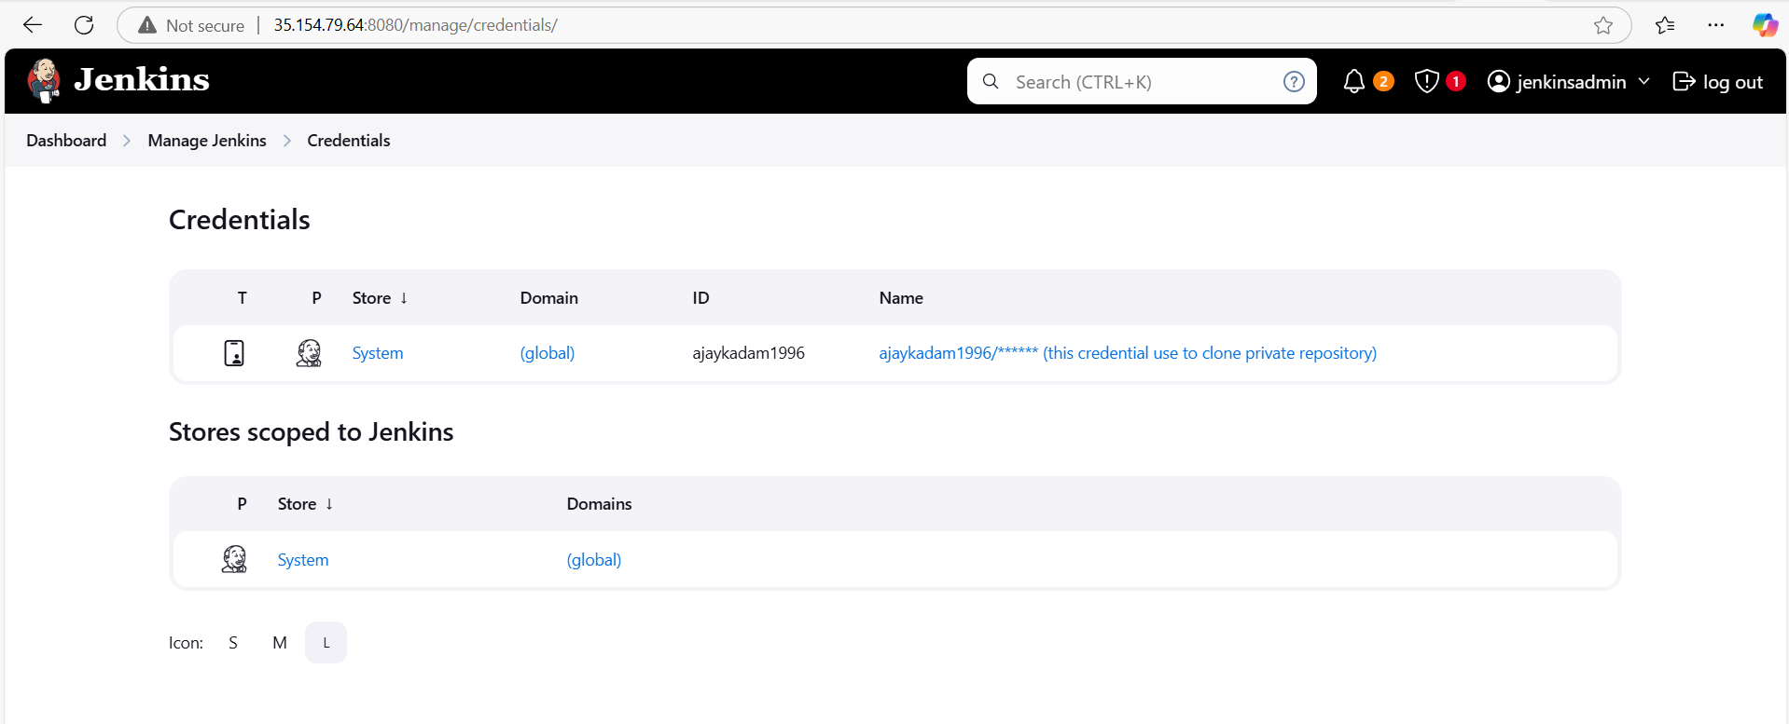

-Go to add global credentials and click on create credentials

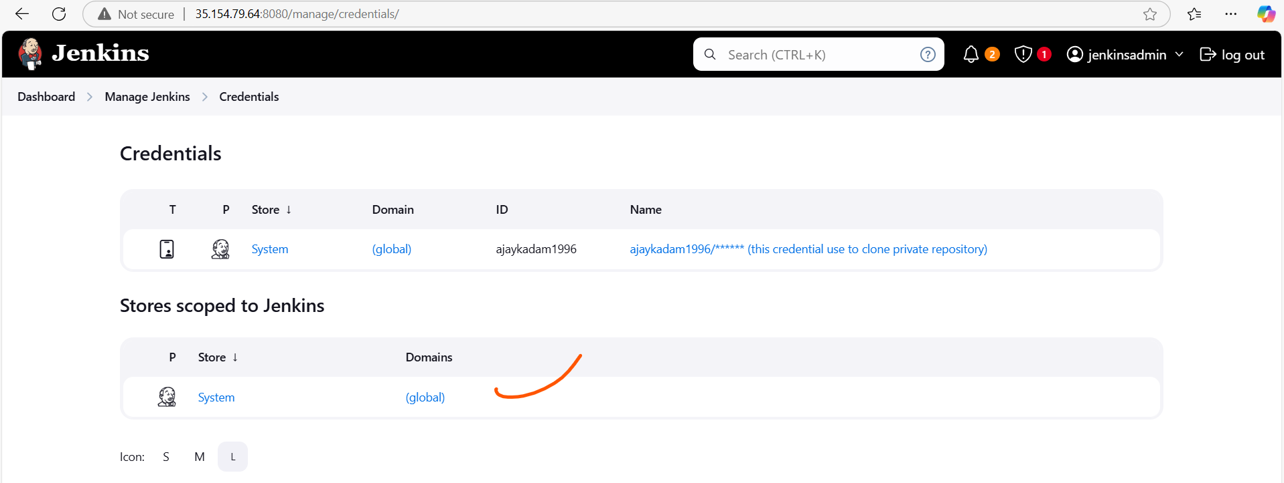

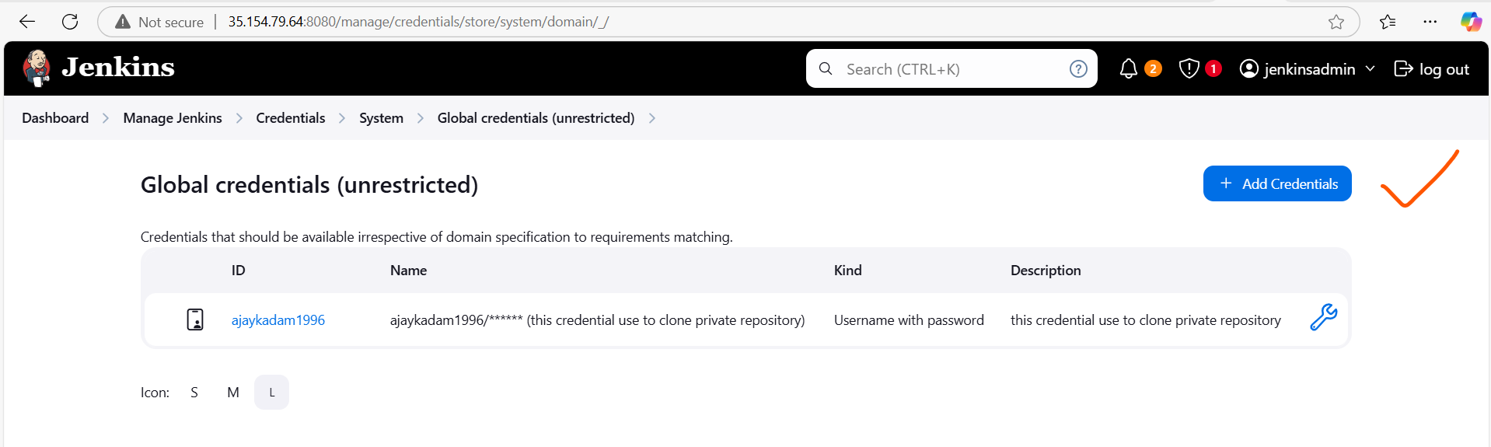

Then select Kind as SSH Username, add user name details, add slave private key manually and

And save the changes your key will be created now

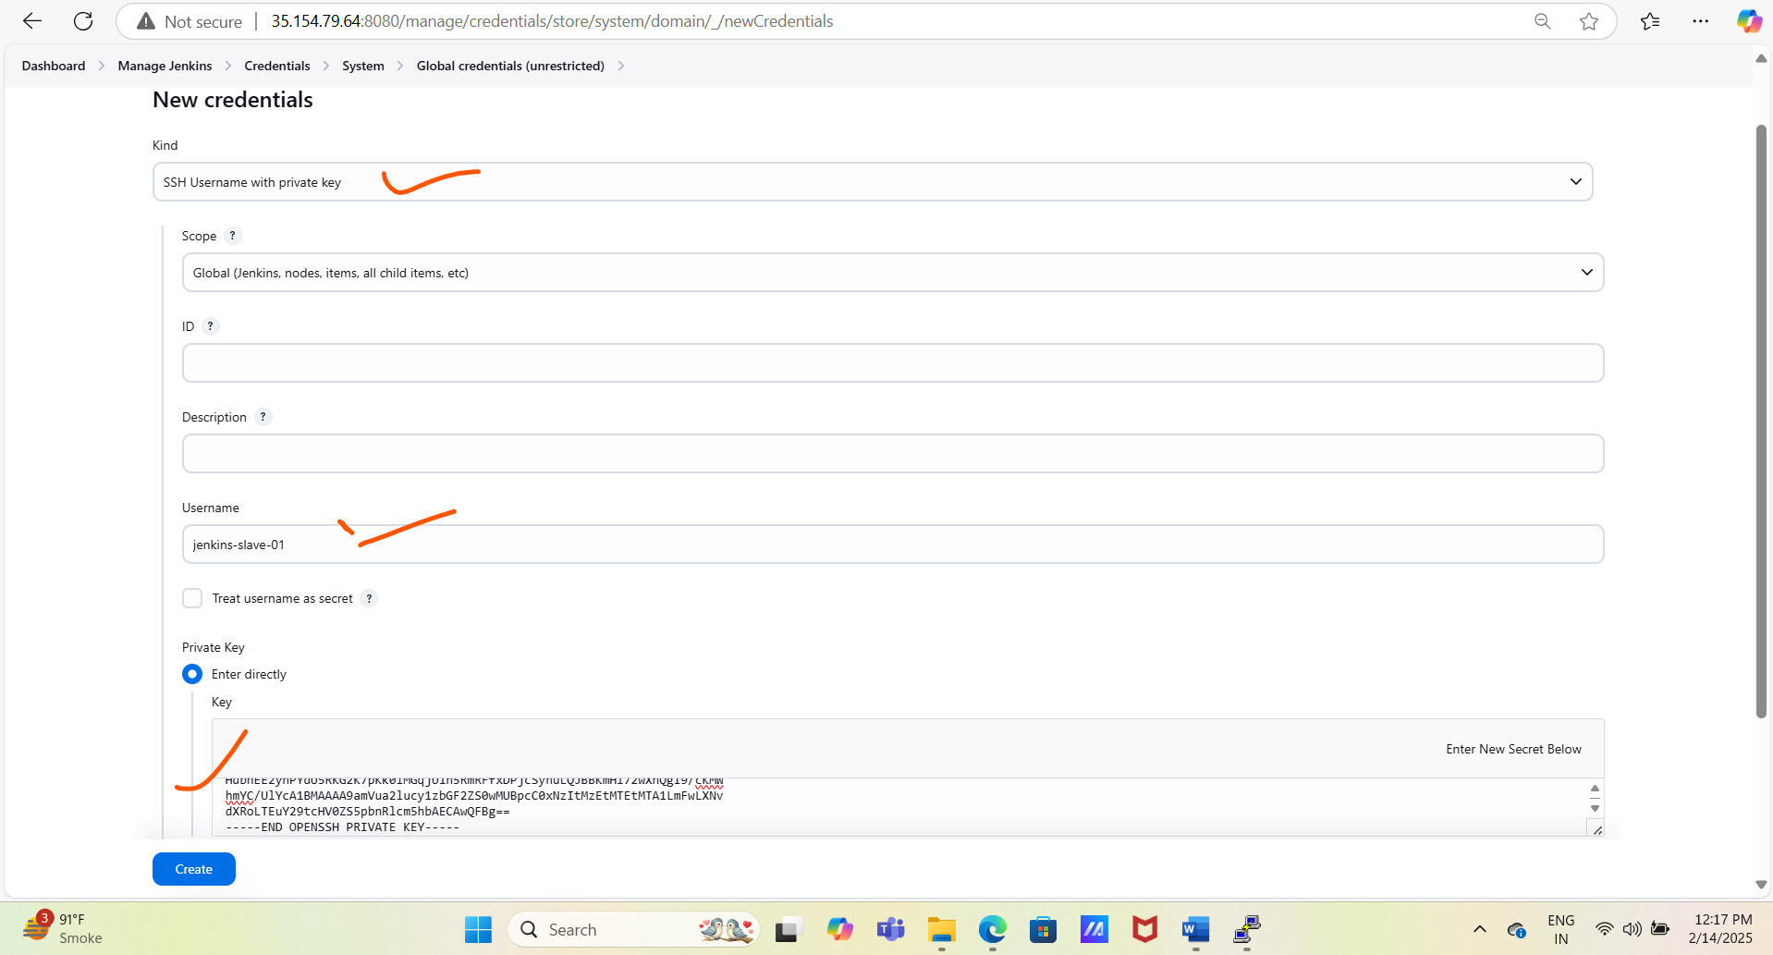

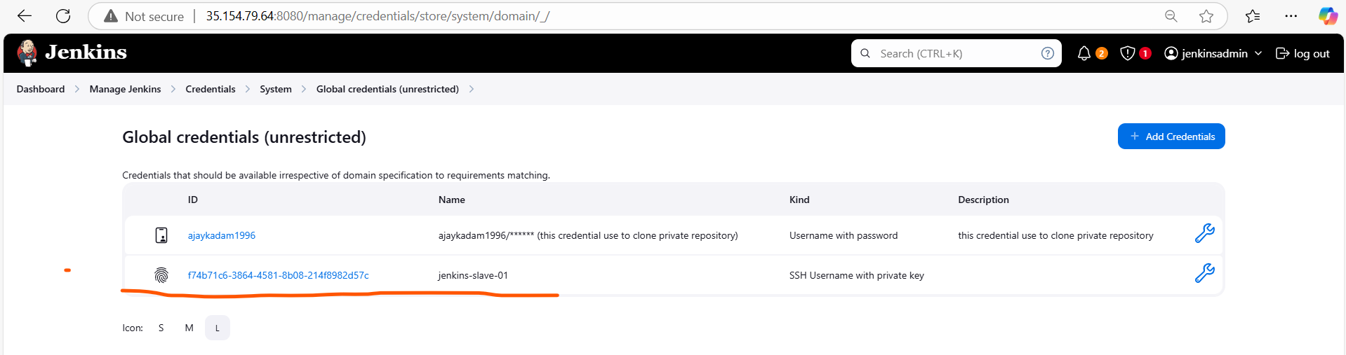

Add newly created key (credentials) and save the changes

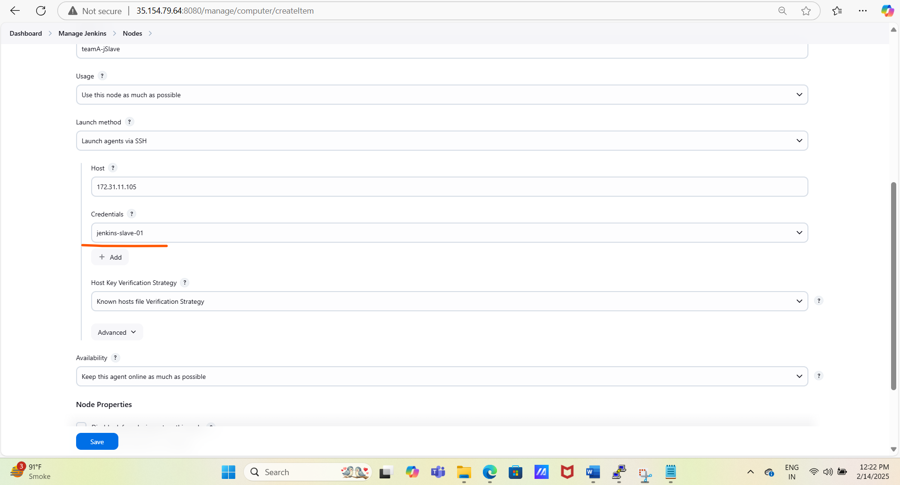

Once we save the changes then Jenkins master will try to connect with the slave Jenkins server.

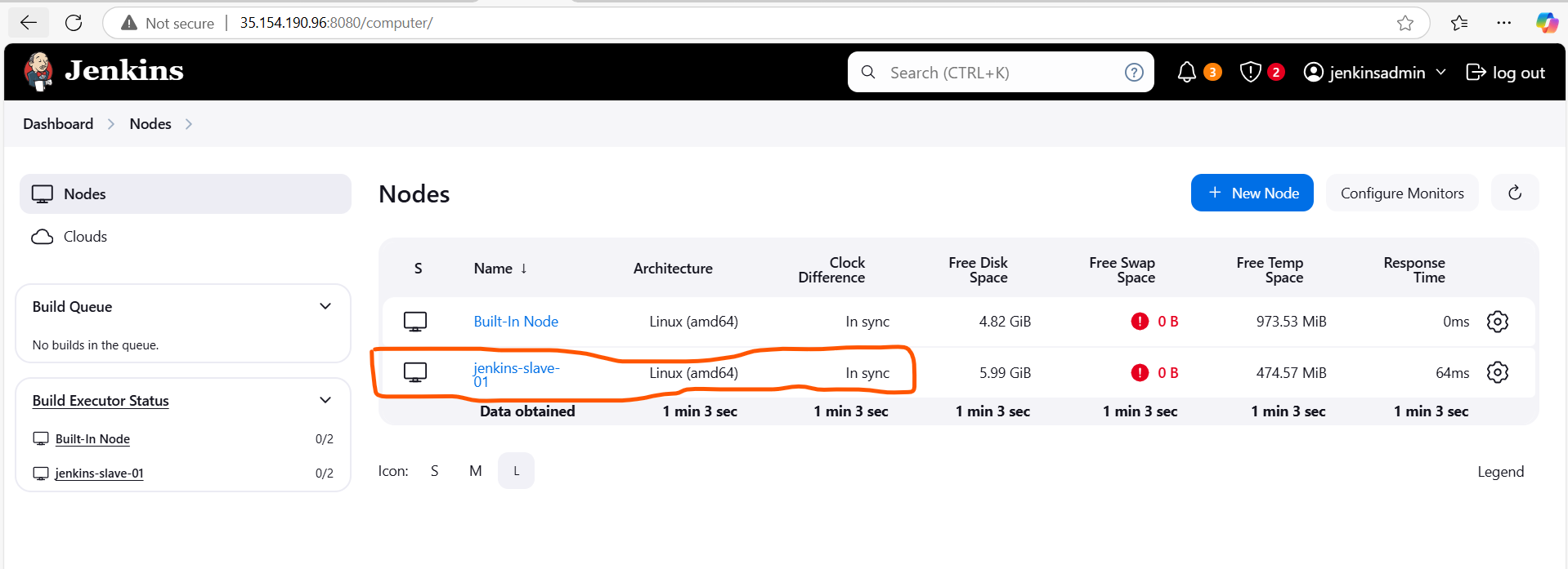

# Now if we want to run our pipeline on the Jenkins newly created slave then

Copy the Jenkins slave label name and add this in the Jenkins file (Microservice Booking_MS)

* agent { label 'teamA-jSlave' }

Push new changes and run pipeline using below commands.

* Git status
* Git diff
* Git add –all
* Git commit -m “added label in place of agent any”
* Git push origin dev

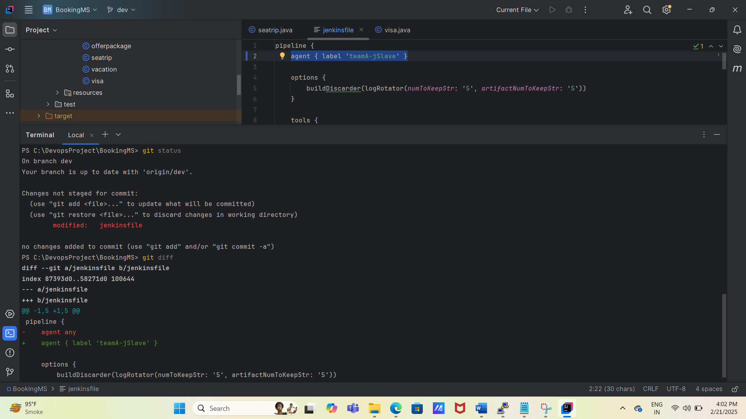

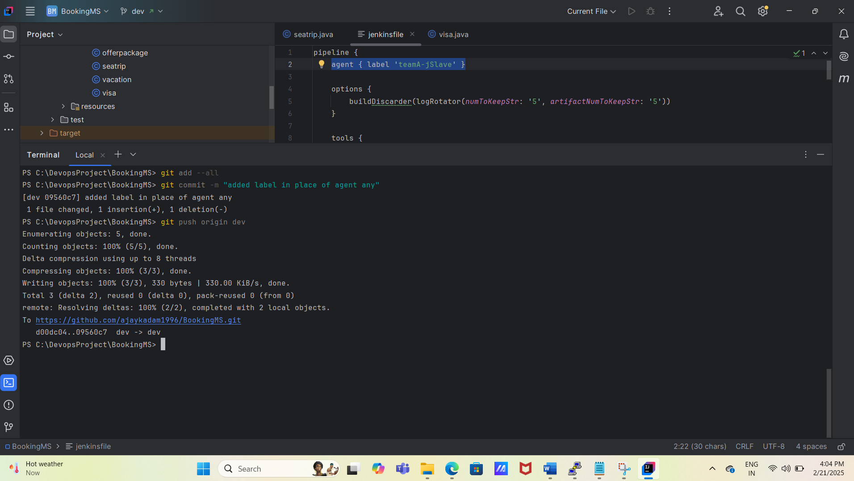

# We can check the pipeline job running status on Jenkins stage view

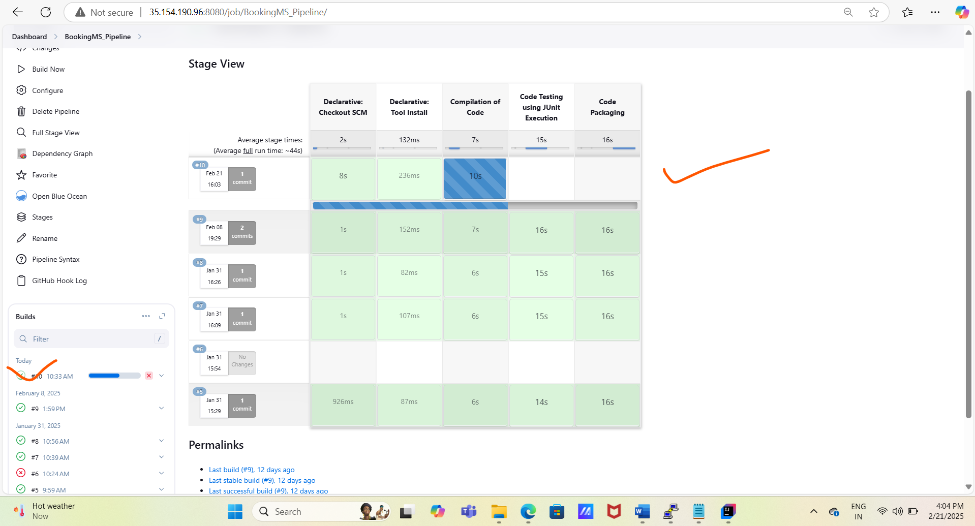

#Also we can verify the job is running on master Jenkins or slave Jenkins with the help of job console logs

